**Name :**

**Roll no :**

**Group A Lab Assignment:** 4.1

**Subject :**PSDL

**Title:** Multiply 8 bit number by 8 bit number

**Assignment No: 4.1**

**Title :** Embedded C menu driven Program for Multiplying 8 bit number by 8 bit number.

**Aim:** Write an Embedded C menu driven Program for Multiplying 8 bit number by 8 bit number.

**Objective:** To develop and execute embedded C program for multiplication operation for 8 bit number by 8 bit number for PIC18FXXX microcontrollers**.**

**Theory:**

PIC 18F is optimized for C programming. n 16F PIC Microcontrollers we have two registers to control IO pins, which are TRIS and PORT. TRIS is used to control direction (Input or Output) of each IO pin while PORT is used to Write or Read data from IO pins. Whereas in 18F PIC Microcontrollers there is an additional register, **LAT**. LAT stands for Port Latch. As in 16F, 18F also uses TRIS register to control direction of each IO pin. **LAT** register is used to write **Output** and **PORT** register is used read **Inputs**.

PIC18F4550 has a total of 35 I/O (input-output) pins which are distributed among 5 Ports A,B,C,D AND E. Each Port of a **microcontroller** corresponds to three 8-bit registers (TRIS, PORT & LAT) which should be configured to use the Port for general I/O purpose.

To configure a particular port/pin as input, the corresponding TRIS register/TRIS bit should be set to high (1). For output, the relevant TRIS register/bit should be set to low (0).

For example, for PortD to set the entire PortD as input

TRISD = 0xFF;

To set only 3rd pin (RD2) of PortD as input

TRISD.RD2 = 1;

To set the entire PortC as output

TRISC = 0;

To set  1st pin (RD0) as output:

TRISD.RD0 = 0;

**Procedure:**

**Step 1:** Open MPLABX IDE on the PC for program development and create a new project and save it in a new folder.

**Step 2:** Write the program in C language for multiplying 8 bit number by 8 bit number

**Step 3:** Build the program and create hex file. In case of errors correct program and rebuild to create hex file.

**Step 4:** Select Window->Target memory views->**Configuration bits** from tool bar. Select appropriate settings, generate source code and paste the configurations in the main program.

**Step 5:** Select debug project and then Finish debugger session from the tool bar.

**Step 6:** Select Window->Target memory views->**SFRs to view the output.**

**Source code:**

#include<stdio.h>

#include<stdlib.h>

#include<pic18f4550.h>

void main(void)

{

int num1,num2;

int result,i;

result=0;

num1=0x03;

num2=0x10;

for(i=1;i<=num2;i++)

{

result=result+num1;

}

TRISB=0;

PORTB=result;

}

**OUTPUT:**

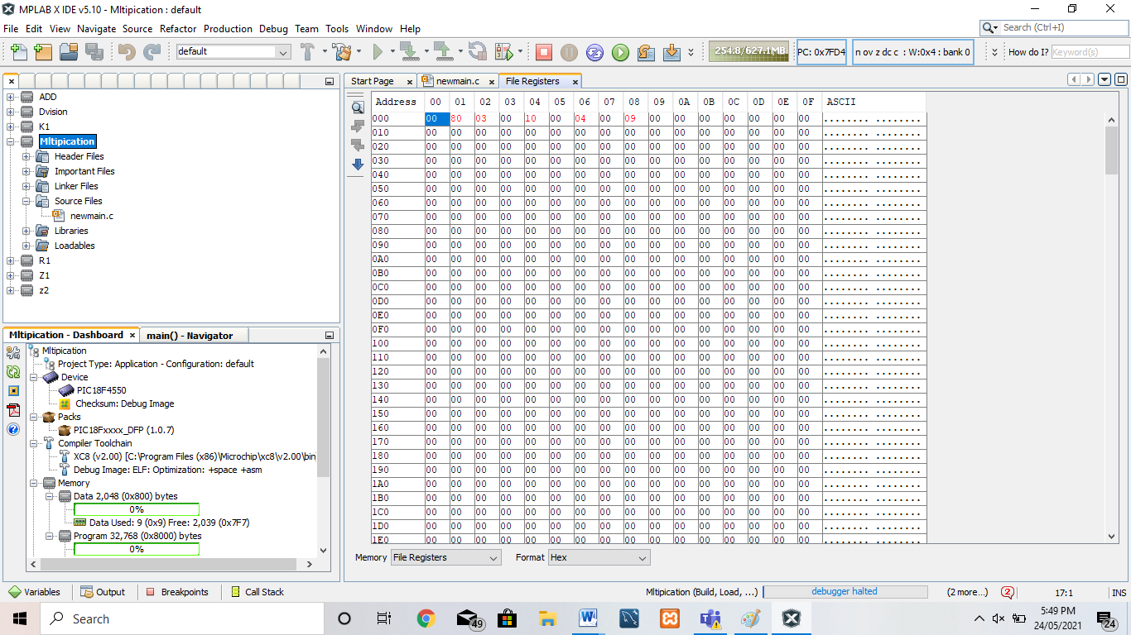

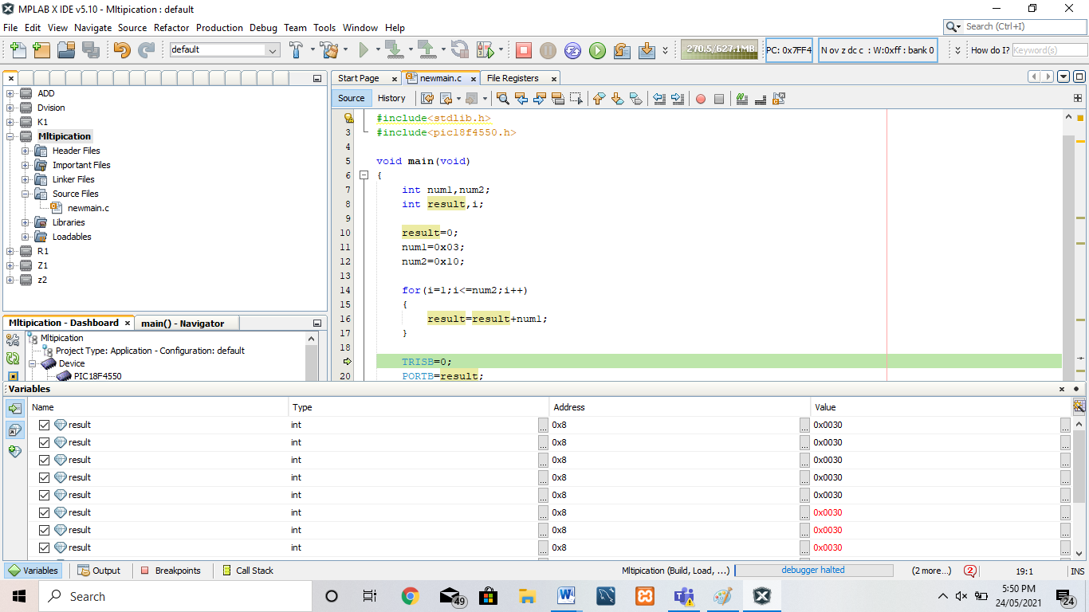

**Conclusion:** Thus, we have studied embedded C menu driven program for multiplying 8 bit number by 8 bit number.